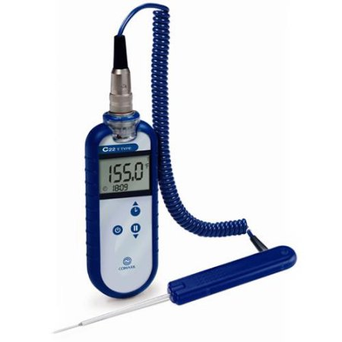

328 - 752F Thermocouple Thermometer

* Digital thermocouple thermometer
* -328 to 752F (-200 to 400C) temperature range
* With temperature probe PT19L
* Waterproof for added versatility
* Clock and countdown timer features
* Screw on T type probe
* Heavy duty
* Uses (2) AA batteries, included